**Research-Based Report**

Alan Love, 23702790

Bachelor of Psychological Science, Southern Cross University

PSYC2005: Advanced Psychological Investigation

Dr Anna Praskova

May 22, 2022

Social media (SM) has altered the way of human interaction by allowing users to socialise across the globe through modern technologies like smartphones and computers. As of 2020, there were 4.14 billion SM users worldwide interacting on SM platforms like Facebook, Twitter, Instagram, and WhatsApp (Wang et al.,2021). Most SM users are young adults, with almost 90% of this population using at least one SM platform (Das-Friebel et al., 2020) and spending approximately 6 hours on SM every day (Hruska & Maresova, 2020). Furthermore, instant communication, rapid information sharing, and overall convenience are SM features appealing to younger generations, particularly university students (Wang et al.,2021). Also, SM provides some benefits to users like relaxation, leisure (Zivnuska, 2019) and keeping in touch with family and friends (Das-Friebel et al., 2020), yet overuse of SM may lead to adverse outcomes like addictive behaviours and poor sleep hygiene (Wang et al.,2021).

Zivnuska (2019) describes SM addiction as overusing, and recurrent checking of SM manifested by compulsive usage behaviours impeding daily functioning and productivity. For example, 64% of adults check their Facebook daily, and smartphone users check Facebook on average about 14 times a day (Zivnuska, 2019). In addition, psychological phenomena like Fear of Missing Out (FoMO) are also related to compulsive SM use, and poor SQ since users are driven to persistently seek connections and acknowledgement from others online (Tandon et al., 2020).

Moreover, studies show that extended periods of SM use at night resulted in delayed sleep times and wake up times, in addition to sleep disturbances like waking up during the night and having trouble getting back to sleep (Das-Friebel et al., 2020). Likewise, research shows that roughly 20% of young adults constantly wake up to check their SM leading to overwhelming exhaustion (Tandon et al., 2020). Additionally, electronic devices emit blue light, which can interfere with melatonin secretion affecting the body's ability to fall asleep (Das-Friebel et al., 2020). Furthermore, a study explains how Taiwanese University students reported poor sleep habits due to online socialising and feeling exhausted the following day. Students also reported negative feelings such as depression, confusion, and irritation, with some students admitting to taking sleeping pills and frequent alcohol consumption (Wang et al.,2021).

Sleep is a crucial aspect of promoting healthy life. It is recommended for most adults to acquire 7-9hours of sleep a night. However, several recent reports find adults are substantially lacking in sleep, feeling unrefreshed after waking and have difficulty falling asleep, ultimately inhibiting daily functioning and resulting in physical health problems (Levenson et al., 2016). Since SM use may be a significant aspect of poor SQ, it is advantageous to investigate this relationship further.

**Aim**

This study aimed to examine the relationship between SM use and SQ. Comparing younger and older adult university students' SM use was also explored.

**Hypothesis**

Based on prior literature, the following propositions were made:

* A relationship between SM use and poor SQ will exist.
* Younger adults will use SM more than older adults.

**Results**

Participants were 85 Southern Cross University students aged 18 to 60 (*M* = 31, *SD* 10.95) collected from convenience sampling methods. Participants were predominantly Anglo-Australian (87.1%) and European (9.4%).

**Table 1**

*Sociodemographic Characteristics of the participants*

|  |  |  |
| --- | --- | --- |
| Characteristics | *n* | % |
| Gender |  |  |
| Female | 69 | 81.2 |
| Male | 14 | 16.5 |
| Non-binary | 2 | 2.4 |
| Total | 85 | 100 |
| Enrolment status (units enrolled in during current session) |  |  |
| One | 7 | 8.2 |
| Two | 23 | 27.1 |
| Three | 38 | 44.7 |
| Four | 17 | 20.0 |
| Total | 85 | 100 |

Firstly, a correlation analysis was conducted in SPSS between SQ composite scores and SM use composite scores to establish a directional relationship (see Figure 1, Figure 2).

**Figure 1**

*Histogram of frequency of SQ composite scores.*    
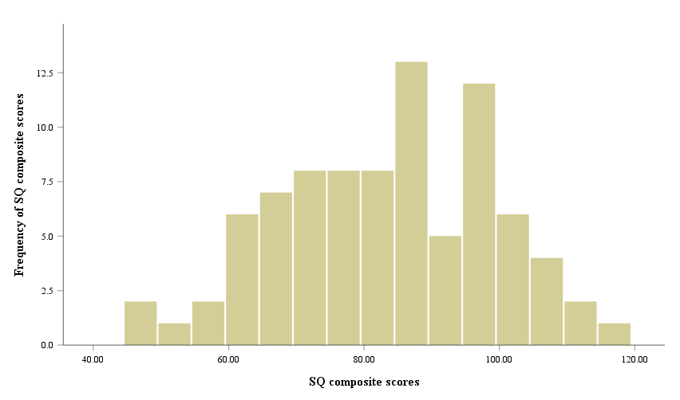

*Note.* Higher composite scores indicate poor SQ.

**Figure 2**

*Histogram of frequency of composite SM use scores.*

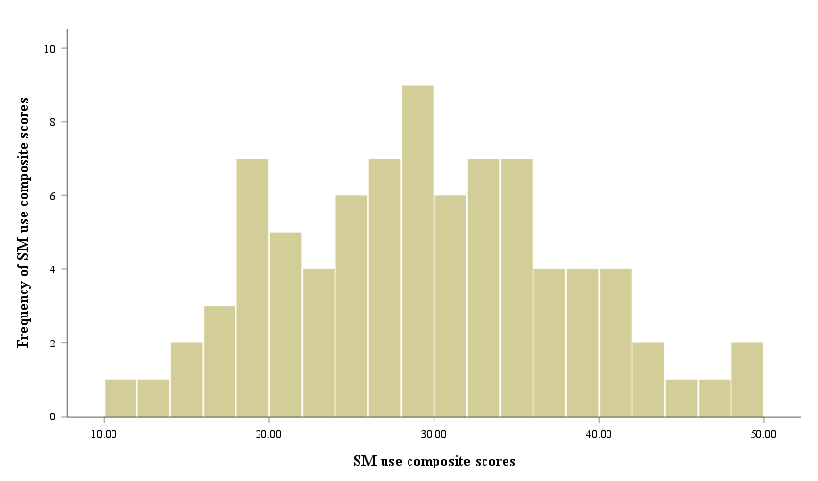

*Note.* Higher composite scores indicate increased SM use

**Table 2**

*Descriptive statistics and correlation coefficient for SM use and SQ composite scores.*

|  |  |  |  |  |  |
| --- | --- | --- | --- | --- | --- |
| Variable | *n* | *M* | *SD* | 1 | 2 |
| Sleep Quality | 85 | 83.36 | 15.52 | - |  |
| Social Media | 83 | 28.90 | 8.48 | .20 | - |

*Note. a = .05.*

Since two participants did not fill out SM questions, SPSS did not include their data in the correlational analysis (see Table 2).

**Figure 3**

*Scatterplot correlation with regression line for SQ and SM use composite scores.*

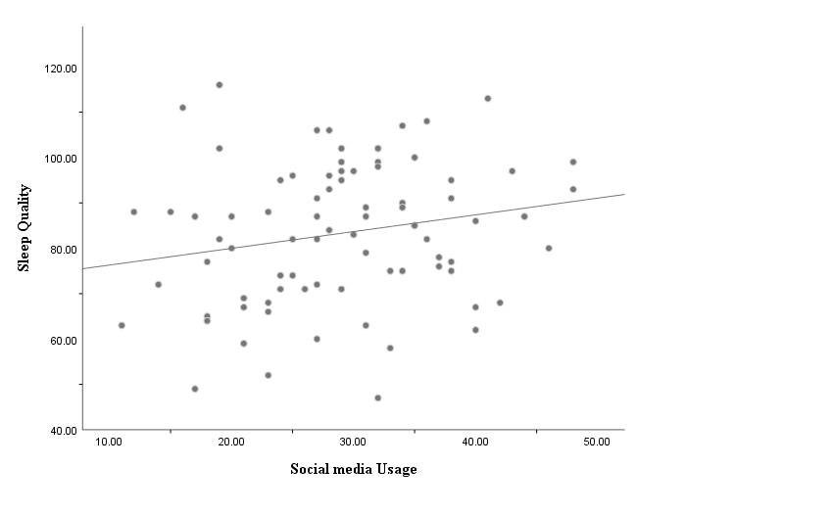

The correlation between SQ and SM usage scores was *r* = .20 (N = 83). This relationship (see Table 2, Figure 3) represents a positively weak and linear correlation according to Cohens (1988) conventions, indicating that as scores on SM use increased, so did scores on SQ. In other words, few students who used increased levels of SM also reported having poor SQ. However, there is insufficient evidence to conclude that a relationship exists between SM use and poor SQ since Pearson's correlational analysis showed non-significant results, *p =* .068, two-tailed.

Finally, an independent sample *t*-test was conducted on SPSS to compare means between younger and older adult groups regarding SM use. A rejection level of a = .05 was set for this test, and age groups were created. Following Erikson's research, the younger adults group fell between 18-39 years (Kessler, 2021), and the older group includes those 40 years and older (see Figure 4).

**Table 3**

*Descriptive statistics for age group differences in SM use composite scores.*

|  |  |  |  |  |  |  |  |
| --- | --- | --- | --- | --- | --- | --- | --- |
| Scale | Age group | n | % | M | SD | SEM | Range |
| SM use | Younger adults | 63 | 74.1 | 30.03 | 7.38 | 0.99 | 15-48 |
|  | Older adults | 19 | 22.4 | 25.47 | 9.87 | 2.26 | 11-48 |
|  | Missing | 3 | 3.5 | - | - | - | - |

*Note.* Since two participants did not fill out the SM questionnaire and one did not indicate their age, three subjects were subtracted from this analysis.

**Figure 4**

*Boxplot comparison on SM use between age groups.*

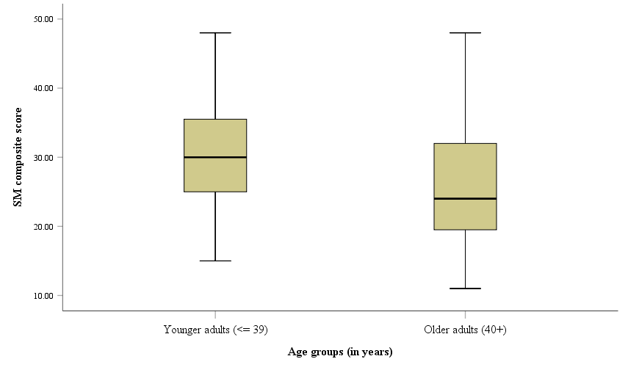

The independent samples *t-*test revealed that younger adults scored higher on social media use than older adults (see Table 3, Figure 4). There is 95% confidence that the mean difference between younger and older age groups (*M =* 4.56, *SE =* 2.18) is statistically significant, *t*(80) *=* 2.09, *p* *=* .040, 95% CI [0.22, 8.90], two-tailed. Additionally, an effect size ( = .52) was calculated, which is a medium effect size according to Cohen (1988). Overall, it is evident to assume that younger adults use SM more than older adults on average.

**Discussion**

Firstly, this study was unable to demonstrate any relationship between SM use and poor SQ, contrary to previous research (Wang et al., 2021; Tandon et al., 2020; Levenson et al., 2016). Differences between this study and previous research may account for dissimilarities. For instance, perhaps this study's insufficient sample size made it difficult to determine the hypothesised outcome (Faber & Fonseca, 2014) compared to prior studies, which had access to superior means of collecting larger samples.

Nevertheless, this study's verdict aligns with Das-Friebel et al. (2020) research which showed no association between SM use and poor SQ. However, Das-Friebel et al. (2020) study used a longitudinal design that they believed attributed to differences in outcomes compared to prior research that used cross-sectional methods, therefore clouding the direction of the relationship between SM and affect. Likewise, a three-year longitudinal study found that SM did not affect SQ, ultimately suggesting that young university students use SM as a coping strategy for their existing sleep problems (Tavernier & Willoughby, 2014). Therefore, caution must be taken when determining any interpretation for this outcome since substantial evidence supports and opposes an association between SM use and poor SQ.

Finally, as predicted, younger adults displayed higher SM use than older adults. This result is consistent with previous research (Tammisalo et al., 2022) and the literature review. Thus, SM use is significantly higher among younger populations.

**Reflection**

**Table 4**

*A reflection on the conduct of the study.*

|  |  |  |
| --- | --- | --- |
| What part of the study?  Describe the aspect of the study that you wish to focus on. | What was the concern? Describe the weakness (or challenge, error, etc.). | What would I do next time? Explain what you would do differently if you were going to run a similar study from scratch. |
| SM Questionnaire | This study used an adapted version of the Bergen Facebook Addiction Scale with additional limited questions relating to social media use. This adaptation did not undergo any scale development and validation process.  Therefore, the results may lack reliability and validity, exceptionally construct validity. | To overcome this limitation would be to find and apply a scale with high psychometric soundness for future research projects. |
| Sample size | This study used a small sample size, making it difficult to determine whether a specific result was significant. Smaller sample sizes increase the risk of a type II error. Thus, researchers reject the alternative hypothesis even though it is true. | Employing a larger sample of over 100 participants can help researchers reduce this complication and avoid the risk of a type II error for future studies. |
| Sampling Method | Given that this study was conducted in such a short period, it fell under certain constraints and was abided to use convenience sampling on psychology students at Southern Cross University since they were easily accessible.  Convenience sampling is considered a biased sampling method and non-representative of the population. Meaning the survey's outcome is difficult to generalise to the broader population.  Additionally, the awareness of Students studying psychology may affect how they answer the survey, like response bias. | Future studies should employ probability sampling techniques that are non-biased and utilise random sampling to rectify this issue. One popular technique is Simple Random Sampling which selects participants by chance and is independent of each other. |
| SM use score | This study used a five-point Likert scale (from never to always) that was used to measure SM use. Since users may have different views on what they consider as low or high amounts of SM use, their responses can be subjective. | Perhaps future research can ask respondents to input how many hours they spend on SM in numerical form to overcome this limitation. |

**References**

Cohen, J. (1988). *Statistical power analysis for the behavioral sciences* (2nd ed.). Erlbaum

Das-Friebel, A., Lenneis, A., Realo, A., Sanborn, A., Tang, N. K. Y., Wolke, D., von Mühlenen, A., & Lemola, S. (2020). Bedtime social media use, sleep, and affective wellbeing in young adults: an experience sampling study. *Journal of Child Psychology and Psychiatry, 61*(10), 1138-1149. https://doi.org/10.1111/jcpp.13326

Faber, J., & Fonseca, L. M. (2014). How sample size influences research outcomes. *Dental Press Journal of Orthodontics, 19*(4), 27-29. <https://doi.org/10.1590/2176-9451.19.4.027-029.ebo>

Hruška, J., & Maresova, P. (2020). Use of social media platforms among adults in the united states—Behavior on social media. *Societies, 10*, 27. <https://doi.org/10.3390/soc10010027>

Kessler, S. (2021, October 20). *What age range is considered a young adult?.* JoinCake. <https://www.joincake.com/blog/young-adult-age-range/>

Levenson, J. C., Shensa, A., Sidani, J. E., Colditz, J. B., & Primack, B. A. (2016). The association between social media use and sleep disturbance among young adults. *Preventive Medicine, 85*, 36-41. https://doi.org/10.1016/j.ypmed.2016.01.001

Rzewnicki, D. I., Shensa, A., Levenson, J. C., Primack, B. A., & Sidani, J. E. (2020). Associations between positive and negative social media experiences and sleep disturbance among young adults. *Sleep Health, 6*(5), 671-675. [https://doi.org/10.1016/j.sleh.2020.02.013](https://doi.org/https://doi.org/10.1016/j.sleh.2020.02.013)

Tammisalo, K., Danielsbacka, M., Andersson, E., & Tanskanen, A. O. (2022). Predictors of social media mse in two family generations. *Frontiers in Sociology, 6*. <https://doi.org/10.3389/fsoc.2021.813765>

Tandon, A., Kaur, P., Dhir, A., & Mäntymäki, M. (2020). Sleepless due to social media? Investigating problematic sleep due to social media and social media sleep hygiene. *Computers in Human Behavior, 113*, 106487. https://doi.org/10.1016/j.chb.2020.106487

Tavernier, R., & Willoughby, T. (2014). Sleep problems: predictor or outcome of media use among emerging adults at university? *Journal of Sleep Research, 23*(4), 389-396. [https://doi.org/10.1111/jsr.12132](https://doi.org/https://doi.org/10.1111/jsr.12132)

Wang, T.-J., Kang, C.-L., Tsai, J.-L., Song, W.-T., & Lien, A. S.-Y. (2021). Social media (Facebook) improper use and the influence of sleeping quality in Taiwan’s university students. *Science Progress, 104*(2), 00368504211011878. <https://doi.org/10.1177/00368504211011878>

Zivnuska, S., Carlson, J. R., Carlson, D. S., Harris, R. B., & Harris, K. J. (2019). Social media addiction and social media reactions: The implications for job performance. *The Journal of Social Psychology, 159*(6), 746-760. <https://doi.org/10.1080/00224545.2019.1578725>